Name: Poorab Gangwani

Section: 2B

Enrollment #:CS191092

**LAB # 9**

**Zener Diode Characteristics & Voltage Regulator using Zener Diode**

**Lab Objectives:**

* To study the characteristics of zener diode when forward & reversed biased
* To understand the operation of zener diode as a voltage regulator

**Apparatus Required:**

* DC Power Supply
* Function Generator
* Digital Multi-meter
* Resistors
* Zener Diode IN4733A
* Oscilloscope
* Connecting wires
* Bread board

**PRE-LAB**

A Zener diode is a diode which allows current to flow in the forward direction in the same manner as an ideal diode, but will also permit it to flow in the reverse direction when the voltage is above a certain value known as the breakdown voltage, "Zener knee voltage" or "Zener voltage" or "avalanche point". Zener diodes of various sorts are used for many purposes, but their most widespread use is as voltage regulators. Once the breakdown voltage of a Zener diode is reached, the voltage across the diode remains almost constant regardless of the supply voltage. Therefore they hold the voltage across the load at a constant level. This characteristic makes Zener diodes ideal voltage regulators.



*Fig. 9.1: Representation of zener diode*

The Zener diode is like a general-purpose signal diode consisting of a silicon PN junction. When biased in the forward direction it behaves just like a normal signal diode passing the rated current, but as soon as a reverse voltage applied across the Zener diode exceeds the rated voltage of the device, the diodes breakdown voltage VB is reached at which point a process called Avalanche Breakdown occurs in the semiconductor depletion layer and a current starts to flow through the diode to limit this increase in voltage.

The current now flowing through the Zener diode increases dramatically to the maximum circuit value (which is usually limited by a series resistor) and once achieved this reverse

saturation current remains fairly constant over a wide range of applied voltages. This breakdown voltage point, VB is called the "Zener voltage" for Zener diodes and can range from less than one volt to hundreds of volts. The point at which the Zener voltage triggers the current to flow through the diode can be very accurately controlled (to less than 1% tolerance) in the doping stage of the diodes semiconductor construction giving the diode a specific Zener breakdown voltage, ( $Vz$) for example, 4.3V or 7.5V. This Zener breakdown voltage on the I-V curve is almost a vertical straight line.

The Zener Diode is used in its "reverse bias" or reverse breakdown mode, i.e. the diodes anode connects to the negative supply. From the I-V characteristics curve in fig. 9.2, we can see that the Zener diode has a region in its reverse bias characteristics of almost a constant negative voltage regardless of the value of the current flowing through the diode and remains nearly constant even with large changes in current as long as the Zener diodes current remains between the breakdown current ($Iz$) minimum and the maximum current rating ($Iz$) max.

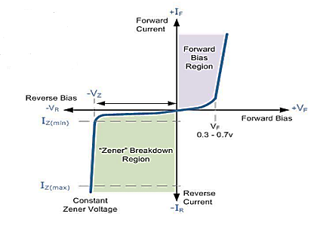

*Fig. 9.2: Zener diode characteristic curve*

**Zener Regulation:**

The ability to keep the reverse voltage across its terminals essentially constant is the key feature of the Zener diode. A Zener diode operating in breakdown acts as a voltage regulator because it maintains a nearly constant voltage across its terminals over a specified range of reverse-current values.

A minimum value of reverse current, $I_{ZK}$ must be maintained in order to keep the diode in breakdown for voltage regulation. You can see on the curve in fig. 9.3 that when the reverse current is reduced below the knee of the curve, the voltage decreases drastically and regulation is lost. Also there is a maximum current, $I_{ZM}$ above which the diode may be damaged due to excessive power dissipation. So basically the Zener diode maintains a nearly constant voltage across its terminals for values of reverse current ranging from $I_{ZK}$ to $I_{ZM}$



*Fig. 9.3: Zener reverse region*

**IN-LAB**

**LAB TASK 1:**

1. Develop the circuit shown in **fig. 9.4a** on breadboard.
2. Increase the voltage of the voltage source in steps of 0.5V.For each Observation, record the current ($I_{1}$) flowing through the circuit and the voltage drop ($V_{z1}$) across the zener diode. Fill up **table 9.1.**
3. Develop the circuit shown in **fig. 9.4b** on breadboard.
4. Increase the voltage of the voltage source in steps of 0.5V. For each Observation, record the current ($I_{2}$) flowing through the circuit and the voltage drop ($V_{z2}$) across the zener diode. Fill up **table 9.1.**

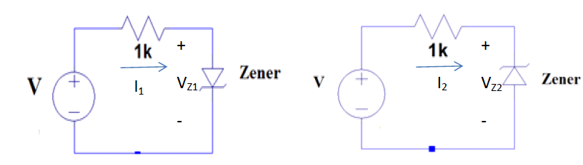

*Fig. 9.4a: Zener forward biased circuit Fig. 9.4b: Zener reverse biased circuit*

**LAB TASK 2:**

1. Develop the circuit shown in **fig. 9.5a** on breadboard, sketch input and output waveforms on the space provided.
2. Develop the circuit shown in **fig. 9.5b** on breadboard sketch input and output waveforms on the space provided.

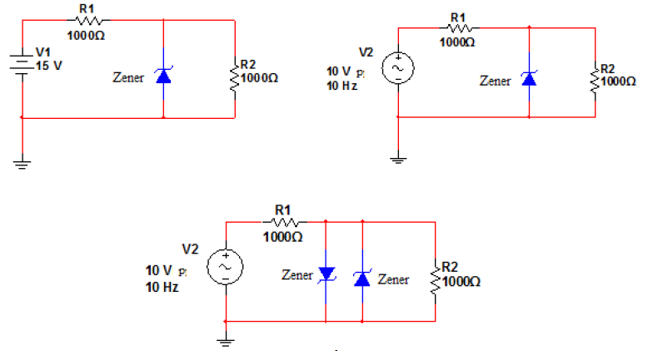

*Fig. 9.5a: Zener as voltage regulator Fig. 9.5b: Zener as voltage regulator*

**LAB TASK 3:**

1. Plot the voltage across zener diode versus the current flowing through it using the values from **table 9.1**. Plot the voltage on the X-axis and the current on the Y-axis.

*Table 9.1: In-lab task 1*

|  |  |  |  |  |
| --- | --- | --- | --- | --- |
| Source Voltage (V) | Observed Current **I1** | Voltage Drop Across Zener Diode **VZ1 (F.B)** | Observed Current **(I2)** | Voltage Drop Across Zener Diode **VZ2 (R.B)** |
| 0.5 | **0.073389mA** | **426.611mv** | **5.55 x 10e-9** | **499.999mv** |
| 1.0 | **0.522615mA** | **477.385mv** | **1.11 x 10e-8** | **999.999mv** |
| 1.5 | **1.006mA** | **494.315mv** | **0A** | **1.500mv** |
| 2.0 | **1.495mA** | **504.577mv** | **0A** | **2000mv** |
| 2.5 | **1.988mA** | **511.943mv** | **0A** | **2500mv** |
| 3.0 | **2.482mA** | **517.686mv** | **0A** | **3000mv** |
| 3.5 | **2.978mA** | **522.392mv** | **4.44 x 10e—8** | **3500mv** |
| 4.0 | **3.474mA** | **526.377mv** | **0A** | **4000mv** |
| 4.5 | **3.97mA** | **529.833mv** | **8.88 x 10e-8** | **4500mv** |
| 5.0 | **4.467mA** | **532.884mv** | **0.0697mA** | **4930mv** |
| 5.5 | **4.964mA** | **535.615mv** | **0.517mA** | **4982mv** |
| 6.0 | **5.462mA** | **538.085mv** | **1.001mA** | **4999mv** |
| 6.5 | **5.96mA** | **540.342mv** | **1.49mA** | **5010mv** |
| 7.0 | **6.458mA** | **542.418mv** | **1.983mA** | **5017mv** |
| 7.5 | **6.956mA** | **544.34mv** | **2.477mA** | **5023mv** |
| 8.0 | **7.454mA** | **546.129mv** | **2.973mA** | **5027mv** |
| 8.5 | **7.952mA** | **547.804mv** | **3.469mA** | **5031mv** |
| 9.0 | **8.451mA** | **549.377mv** | **3.965mA** | **5035mv** |
| 9.5 | **8.949mA** | **550.86mv** | **4.462mA** | **5038mv** |
| 10 | **9.448mA** | **552.262mv** | **4.959mA** | **5041mv** |

**Break down voltage** __________________

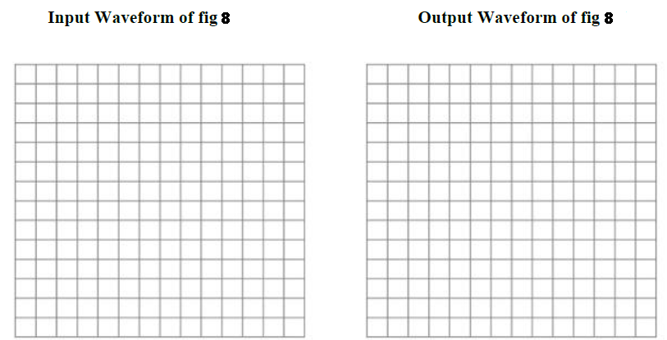

*In-lab task 2: Input and output waveform of fig. 9.5a*



*In-lab task 2: Input and output waveform of fig. 9.5b*

**Conclusion:**

**__________________________________________________________________**

**__________________________________________________________________**

**__________________________________________________________________**

**__________________________________________________________________**

Name: Poorab Gangwani

Enrollment #: CS191092

**POST-LAB ASSIGNMENT # 9**

**Q.1)** Is the characteristic curve of Zener diode linear?

________________________NO___________________________

**Q.2)** what will be voltage across resistor R2? (zener diode is 1N4740a)



____________7.5V______________________________________________________________

**Q.3)** what are the applications of zener diodes?

Ans ) Zener diode are used for voltage regulation and as surge suppressors and as reference elements.

